附件：和田地区策勒县历史遗留废弃矿山基本情况表
序号 | 图斑编号 | 图斑小类 | 地理位置 | 图斑面积（m²） | 中心坐标 |  | 拐点坐标 | 图斑影像
 |  |  |  |  | 经度 | 纬度
1 | CT6532252016000002001 | 无法确认治理恢复责任主体的无主废弃矿山 | 和田地区策勒县奴尔乡以北，策牧公路以东340米处，属于奴尔乡直属。 | 39213.28 | 81.0261 | 36.486416 | 1,4039597.15,27502384.97；  2,4039602.21,27502425.23；  3,4039578.43,27502427.84；  4,4039583.34,27502488.54；  5,4039549.24,27502490.67；  6,4039542.68,27502426.42；  7,4039429.48,27502420.81；  8,4039431.61,27502333.19；  9,4039388.10,27502307.37；  10,4039389.25,27502275.07；  11,4039447.09,27502276.43；  12,4039444.16,27502249.98；  13,4039400.96,27502251.09；  14,4039421.67,27502214.62；  15,4039526.74,27502232.14；  16,4039582.08,27502306.03；  17,4039658.41,27502330.42；  18,4039661.81,27502364.45；  19,4039629.06,27502394.25 | 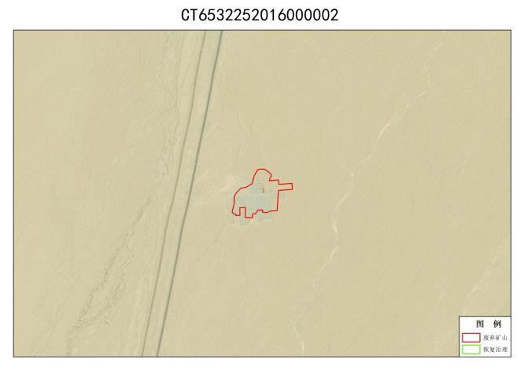
2 | CT6532252016000003001 | 无法确认治理恢复责任主体的无主废弃矿山 | 和田地区策勒县奴尔乡以北，策牧公路以东30米处，属于奴尔乡直属。 | 16925.34 | 81.04942 | 36.618683 | 1,4054132.72,27504423.29；  2,4054124.72,27504377.36；  3,4054144.47,27504347.74；  4,4054231.88,27504348.79；  5,4054278.71,27504478.57；  6,4054221.73,27504471.71；  7,4054199.06,27504502.04；  8,4054165.57,27504502.39 | 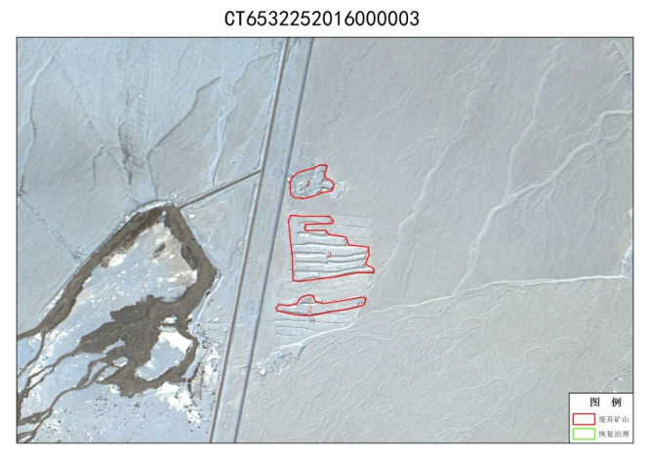
3 | CT6532252016000003002 | 无法确认治理恢复责任主体的无主废弃矿山 | 和田地区策勒县奴尔乡以北，策牧公路以东62米处，属于奴尔乡直属。 | 16415.56 | 81.04978 | 36.613613 | 1,4053645.19,27504469.49；  2,4053670.17,27504625.17；  3,4053633.22,27504602.12；  4,4053592.56,27504438.98；  5,4053594.65,27504364.45；  6,4053610.95,27504300.87；  7,4053639.90,27504304.13；  8,4053645.80,27504371.39；  9,4053677.39,27504389.70；  10,4053685.71,27504414.54
4 | CT6532252016000003003 | 无法确认治理恢复责任主体的无主废弃矿山 | 和田地区策勒县奴尔乡以北，策牧公路以东74米处，属于奴尔乡直属。 | 60782.03 | 81.04994 | 36.61585 | 1,4054006.85,27504401.17；  2,4053979.35,27504400.78；  3,4053979.89,27504476.83；  4,4053961.47,27504486.44；  5,4053948.59,27504550.65；  6,4053913.33,27504561.31；  7,4053903.08,27504633.81；  8,4053824.13,27504621.86；  9,4053800.85,27504655.02；  10,4053785.98,27504653.84；  11,4053742.67,27504362.57；  12,4054044.99,27504339.51；  13,4054044.10,27504489.71；  14,4054019.76,27504506.03
5 | CT6532252016000004001 | 无法确认治理恢复责任主体的无主废弃矿山 | 和田地区策勒县策勒镇以南，策牧公路以南100米处，属于策勒镇直属。 | 57189.49 | 80.85207 | 36.92253 | 1,4088034.12,27486805.76；  2,4087978.51,27486982.55；  3,4087843.35,27486930.23；  4,4087810.18,27486966.98；  5,4087751.92,27486954.60；  6,4087832.24,27486834.57；  7,4087838.33,27486810.52；  8,4087820.54,27486796.43；  9,4087870.82,27486682.53；  10,4088008.30,27486664.55；  11,4087997.75,27486711.70；  12,4088051.48,27486719.30；  13,4088066.26,27486698.93；  14,4088084.79,27486711.28 | 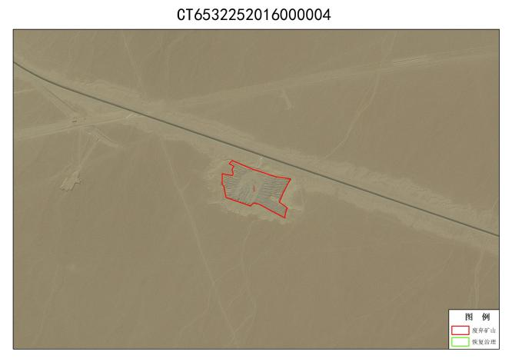
6 | CT6532252016000005001 | 无法确认治理恢复责任主体的无主废弃矿山 | 和田地区策勒县策勒乡，G315以南1千米处，属于策勒乡直属。 | 15921.58 | 80.79273 | 36.912766 | 1,4086913.48,27481589.51；  2,4086799.75,27481595.02；  3,4086774.71,27481539.95；  4,4086791.65,27481500.43；  5,4086766.70,27481481.46；  6,4086768.29,27481469.04；  7,4086864.02,27481462.05；  8,4086929.30,27481478.45 | 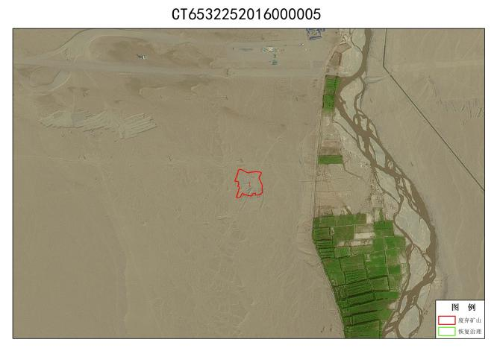
7 | CT6532252016000006001 | 无法确认治理恢复责任主体的无主废弃矿山 | 和田地区策勒县策勒乡，G315以南635米处，属于策勒乡直属。 | 55729.73 | 80.78462 | 36.91631 | 1,4087283.16,27480762.44；  2,4087326.06,27480898.13；  3,4087258.07,27480925.66；  4,4087295.42,27481015.21；  5,4087215.55,27481080.48；  6,4087142.14,27480904.99；  7,4087214.40,27480828.06；  8,4087183.56,27480724.36；  9,4087217.30,27480723.28；  10,4087212.74,27480550.84；  11,4087250.47,27480512.54；  12,4087332.64,27480651.03 | 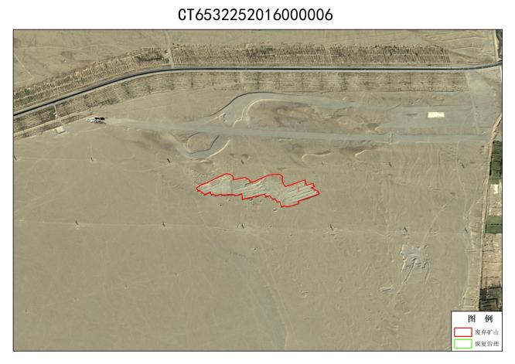
8 | CT6532252016000007001 | 无法确认治理恢复责任主体的无主废弃矿山 | 和田地区策勒县奴尔乡托万阿其玛村以东400米处，属于奴尔乡直属。 | 191682.52 | 81.01547 | 36.343178 | 1,4023862.40,27501322.45；  2,4023835.64,27501554.46；  3,4023700.06,27501549.17；  4,4023629.30,27501431.01；  5,4023321.82,27501498.77；  6,4023482.24,27501614.52；  7,4023394.14,27501676.00；  8,4023270.63,27501559.02；  9,4023057.25,27501596.77；  10,4022968.21,27501473.40；  11,4023683.74,27501270.18；  12,4024120.10,27501087.16；  13,4024165.86,27501231.39 | 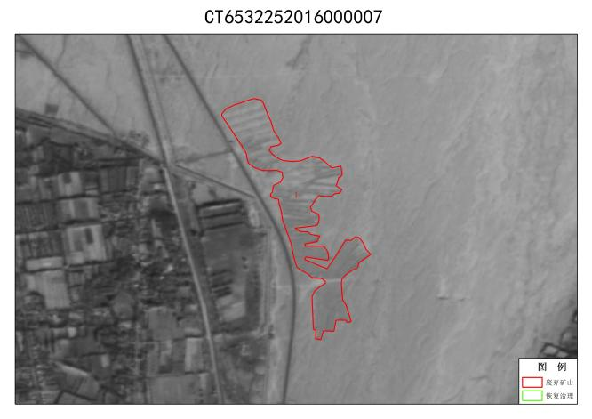
9 | CT6532252016000008001 | 无法确认治理恢复责任主体的无主废弃矿山 | 和田地区策勒县奴尔乡以北，策牧公路以东200米处，属于奴尔乡直属。 | 44530.28 | 81.01293 | 36.408592 | 1,4030998.24,27501131.10；  2,4030999.81,27501217.22；  3,4030938.24,27501246.42；  4,4030954.40,27501290.53；  5,4030940.28,27501299.55；  6,4030885.82,27501239.55；  7,4030844.14,27501262.44；  8,4030787.23,27501224.15；  9,4030789.41,27501282.89；  10,4030773.48,27501288.40；  11,4030749.82,27501173.23；  12,4030711.69,27501131.23；  13,4030801.06,27501100.29；  14,4030837.37,27501052.38；  15,4030898.71,27501080.25；  16,4031013.88,27501056.58；  17,4031036.77,27501098.27 | 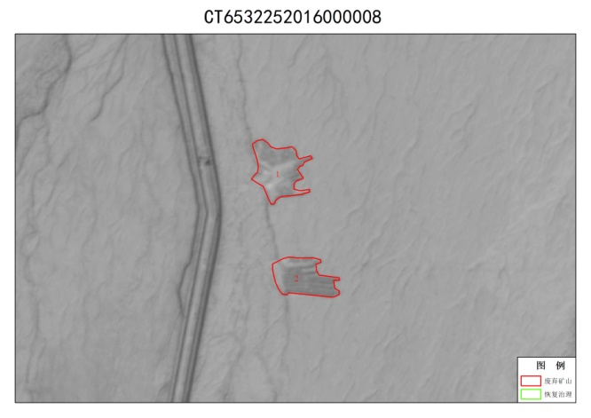
10 | CT6532252016000008002 | 无法确认治理恢复责任主体的无主废弃矿山 | 和田地区策勒县奴尔乡以北，策牧公路以东256米处，属于奴尔乡直属。 | 38739.35 | 81.01406 | 36.40373 | 1,4030446.21,27501204.84；  2,4030432.62,27501332.49；  3,4030378.31,27501315.59；  4,4030329.44,27501385.84；  5,4030258.54,27501408.01；  6,4030259.36,27501177.19；  7,4030411.64,27501138.53
11 | CT6532252017000002001 | 无法确认治理恢复责任主体的无主废弃矿山 | 和田地区策勒县策勒镇，策勒县工业园区以北，策勒镇恰合玛村以南125米处，属于策勒镇直属。 | 9249.86 | 80.841576 | 37.001316 | 1,4096629.47,27485936.81；  2,4096628.98,27485888.75；  3,4096596.74,27485878.98；  4,4096590.86,27485861.05；  5,4096631.07,27485844.66；  6,4096732.56,27485883.87；  7,4096730.55,27485943.88 | 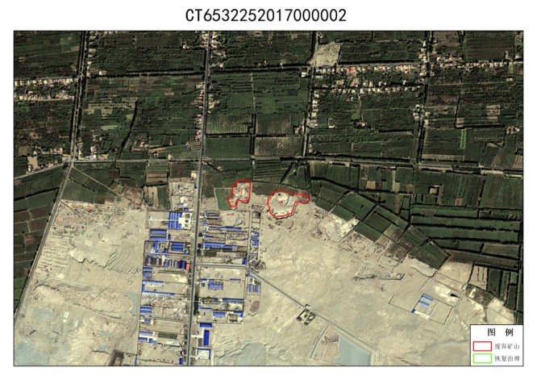
12 | CT6532252017000002002 | 无法确认治理恢复责任主体的无主废弃矿山 | 和田地区策勒县策勒镇，策勒县工业园区以北，策勒镇恰合玛村以南171米处，属于策勒镇直属。 | 16593.79 | 80.84379 | 37.000816 | 1,4096623.30,27486204.26；  2,4096616.22,27486143.87；  3,4096555.53,27486128.64；  4,4096536.38,27486049.62；  5,4096569.97,27486028.98；  6,4096629.60,27486022.24；  7,4096679.20,27486062.23；  8,4096650.43,27486198.85
13 | CT6532252017000003001 | 无法确认治理恢复责任主体的无主废弃矿山 | 和田地区策勒县奴尔乡以北，策牧公路以东4.89千米处，属于奴尔乡直属。 | 136956.98 | 81.122345 | 36.7102 | 1,4064628.73,27510954.67；  2,4064492.67,27511084.96；  3,4064488.72,27511153.64；  4,4064415.87,27511179.28；  5,4064098.16,27510901.95；  6,4064047.33,27510765.77；  7,4064083.34,27510708.03；  8,4064120.80,27510715.58；  9,4064233.74,27510641.77；  10,4064224.66,27510686.60；  11,4064121.35,27510745.27；  12,4064152.54,27510810.68；  13,4064260.38,27510771.54；  14,4064442.63,27510907.39；  15,4064549.43,27510788.39；  16,4064653.11,27510822.36 | 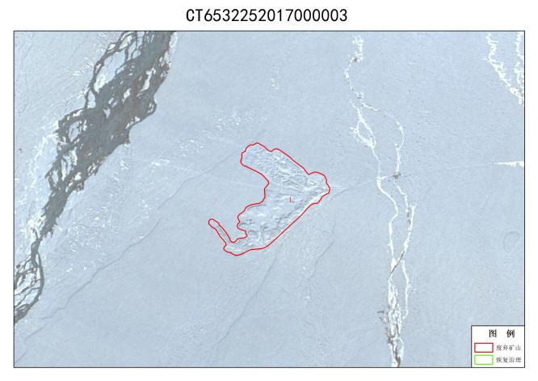
14 | CT6532252017000004001 | 无法确认治理恢复责任主体的无主废弃矿山 | 和田地区和田地区策勒县固拉合玛镇以南，策牧公路以北786米处，属于固拉合玛镇直属。 | 25178.08 | 81.07871 | 36.76295 | 1,4070324.31,27507022.04；  2,4070201.06,27507104.73；  3,4070176.38,27507066.00；  4,4070136.57,27507137.85；  5,4070103.01,27507133.62；  6,4070124.11,27507091.08；  7,4070091.04,27507052.48；  8,4070149.59,27506977.66；  9,4070247.52,27506935.15；  10,4070320.99,27506978.32 | 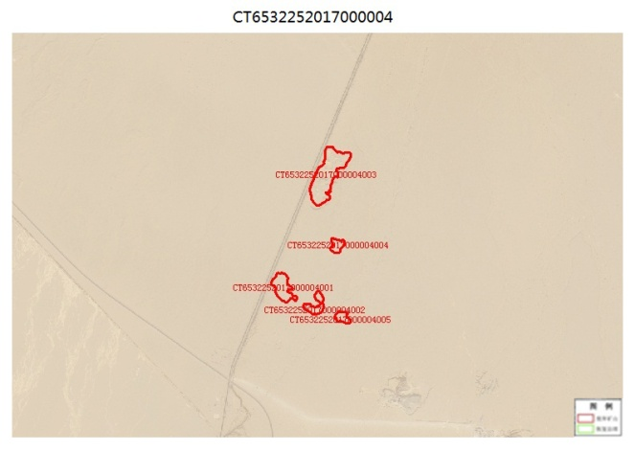
15 | CT6532252017000004002 | 无法确认治理恢复责任主体的无主废弃矿山 | 和田地区和田地区策勒县固拉合玛镇以南，策牧公路以北870米处，属于固拉合玛镇直属。 | 13393.97 | 81.08162 | 36.761723 | 1,4070028.19,27507343.43；  2,4069994.29,27507283.22；  3,4070021.71,27507228.75；  4,4070066.90,27507187.17；  5,4070078.73,27507233.71；  6,4070055.27,27507278.34；  7,4070067.36,27507319.31；  8,4070140.03,27507277.48；  9,4070179.06,27507318.36；  10,4070125.66,27507349.72
16 | CT6532252017000004003 | 无法确认治理恢复责任主体的无主废弃矿山 | 和田地区和田地区策勒县固拉合玛镇以南，战斗渠公路以东15米处，属于固拉合玛镇直属。 | 70098.88 | 81.08267 | 36.771008 | 1,4071280.15,27507552.75；  2,4071247.96,27507563.89；  3,4071160.50,27507514.14；  4,4071072.88,27507427.58；  5,4070911.07,27507399.62；  6,4070860.40,27507292.24；  7,4070911.79,27507252.36；  8,4071009.68,27507246.20；  9,4071189.66,27507352.56；  10,4071325.16,27507377.12
17 | CT6532252017000004004 | 无法确认治理恢复责任主体的无主废弃矿山 | 和田地区和田地区策勒县固拉合玛镇以南，战斗渠公路以东360米处，属于固拉合玛镇直属。 | 9082.89 | 81.08351 | 36.76596 | 1,4070584.98,27507474.27；  2,4070571.09,27507513.72；  3,4070485.77,27507477.07；  4,4070498.35,27507411.18；  5,4070596.72,27507413.03
18 | CT6532252017000004005 | 无法确认治理恢复责任主体的无主废弃矿山 | 和田地区和田地区策勒县固拉合玛镇以南，战斗渠公路以东582米处，属于固拉合玛镇直属。 | 7704.95 | 81.084015 | 36.76082 | 1,4070018.11,27507478.28；  2,4070005.57,27507538.38；  3,4069926.73,27507561.14；  4,4069940.91,27507458.67；  5,4069982.27,27507436.11
19 | CT6532252017000008001 | 无法确认治理恢复责任主体的无主废弃矿山 | 和田地区和田地区策勒县恰哈乡都维力克村西北1.8千米处，属于恰哈乡直属。 | 72036.36 | 80.66444 | 36.51211 | 1,4042473.46,27469909.41；  2,4042381.43,27470009.51；  3,4042233.03,27469985.60；  4,4042095.92,27469904.40；  5,4042193.30,27469806.41；  6,4042495.65,27469883.43；  7,4042531.78,27469863.56；  8,4042755.10,27470016.05；  9,4042826.23,27470082.37；  10,4042807.04,27470110.81；  11,4042733.53,27470049.51；  12,4042684.24,27470085.55 | 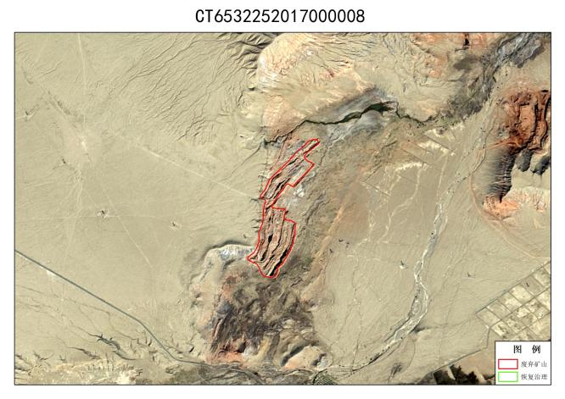
20 | CT6532252018000001001 | 无法确认治理恢复责任主体的无主废弃矿山 | 和田地区策勒县博斯坦乡以南，博斯坦河以南80米处，博斯坦乡直属。 | 21246.94 | 81.37215 | 35.585083 | 1,3939645.88,27533660.82；  2,3939629.12,27533837.67；  3,3939603.29,27533857.86；  4,3939555.39,27533794.71；  5,3939475.04,27533809.53；  6,3939484.19,27533755.93；  7,3939527.69,27533742.66；  8,3939501.18,27533689.32；  9,3939570.24,27533655.08；  10,3939550.35,27533598.85 | 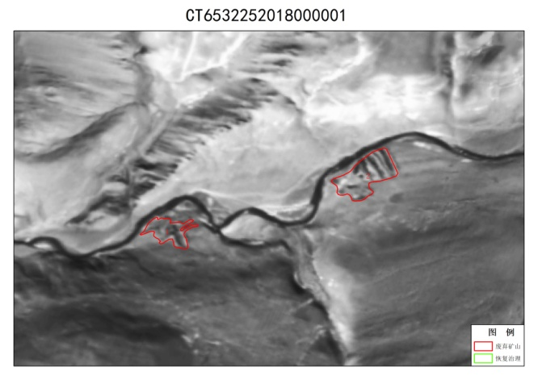
21 | CT6532252018000001002 | 无法确认治理恢复责任主体的无主废弃矿山 | 和田地区策勒县博斯坦乡以南，博斯坦河以南40米处，博斯坦乡直属。 | 43033.85 | 81.38193 | 35.587868 | 1,3939785.20,27534645.89；  2,3939741.24,27534585.55；  3,3939776.80,27534487.87；  4,3939851.00,27534456.69；  5,3940036.56,27534698.34；  6,3939893.47,27534757.23；  7,3939839.87,27534627.33
22 | ZJ6532252021001001 | 无法确认治理恢复责任主体的无主废弃矿山 | 和田地区策勒县策勒乡托帕村以西，和若铁路以南170米处。策勒乡直属。 | 310495.38 | 80.7181 | 36.993828 | 1,4096150.54,27474561.17；  2,4096179.27,27475022.58；  3,4096013.70,27475292.79；  4,4095924.22,27475553.07；  5,4095704.40,27475408.82；  6,4095599.25,27475065.36；  7,4095686.72,27474836.09；  8,4096048.48,27474779.46；  9,4096050.68,27474573.58 | 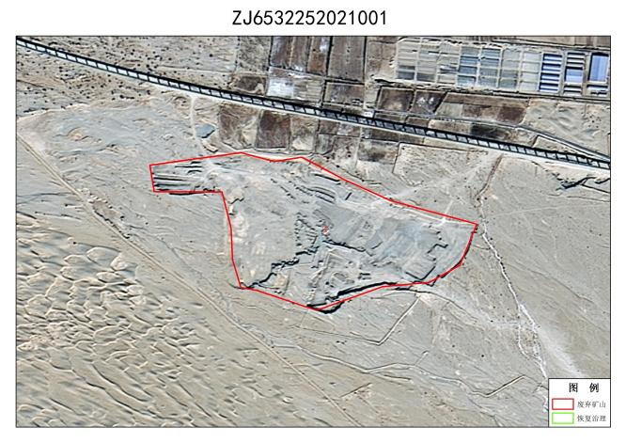
23 | ZJ6532252021002001 | 无法确认治理恢复责任主体的无主废弃矿山 | 和田地区策勒县策勒乡托帕村以南，和若铁路以南447米处。策勒乡直属。 | 53941.47 | 80.74866 | 36.98795 | 1,4095335.23,27477442.69；  2,4095261.71,27477682.29；  3,4095195.81,27477838.03；  4,4095062.94,27477753.79；  5,4095118.20,27477630.22；  6,4095213.81,27477423.73 | 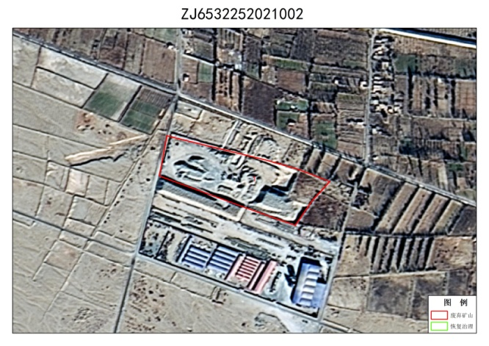
24 | ZJ6532252021004001 | 无法确认治理恢复责任主体的无主废弃矿山 | 和田地区策勒县策勒镇，策牧公路以南453米处，属于策勒镇直属。 | 48040.61 | 80.84244 | 36.92284 | 1,4087956.11,27486053.83；  2,4087800.16,27486147.92；  3,4087793.37,27486265.58；  4,4087755.05,27486280.36；  5,4087735.53,27486105.42；  6,4087845.33,27485977.32；  7,4087824.26,27485945.49；  8,4087903.66,27485834.31；  9,4088044.82,27485962.66 | 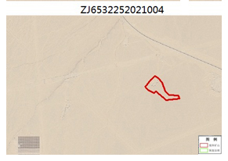
25 | ZJ6532252021005001 | 无法确认治理恢复责任主体的无主废弃矿山 | 和田地区策勒县策勒镇，和若铁路以南253米处，属于策勒镇直属 | 151082.66 | 80.86759 | 36.95951 | 1,4092194.71,27488157.71；  2,4092132.99,27488489.89；  3,4091942.84,27488503.20；  4,4091873.39,27488313.23；  5,4091888.59,27488019.96；  6,4092000.73,27487889.58；  7,4092070.46,27487882.89 | 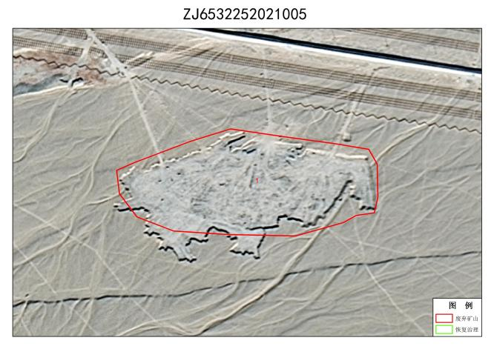
26 | ZJ6532252021006001 | 无法确认治理恢复责任主体的无主废弃矿山 | 和田地区策勒县策勒镇和若铁路南侧，属于策勒镇直属。 | 53983.11 | 80.889786 | 36.95882 | 1,4092068.36,27490147.67；  2,4092060.26,27490300.24；  3,4092024.56,27490344.70；  4,4091838.46,27490290.45；  5,4091838.71,27490071.11；  6,4091886.27,27490045.74；  7,4092009.06,27490045.88 | 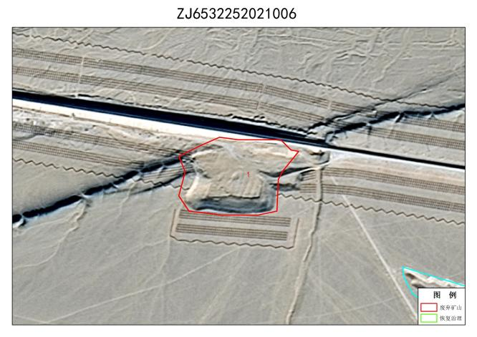
27 | ZJ6532252021007001 | 无法确认治理恢复责任主体的无主废弃矿山 | 和田地区策勒县固拉合玛镇，和若铁路以南344米处，属于固拉合玛镇直属。 | 45664.6 | 80.89634 | 36.955227 | 1,4091664.41,27490602.47；  2,4091527.90,27490937.27；  3,4091381.94,27490740.87；  4,4091286.68,27490743.66；  5,4091329.55,27490575.77；  6,4091483.54,27490771.03；  7,4091583.84,27490625.69 | 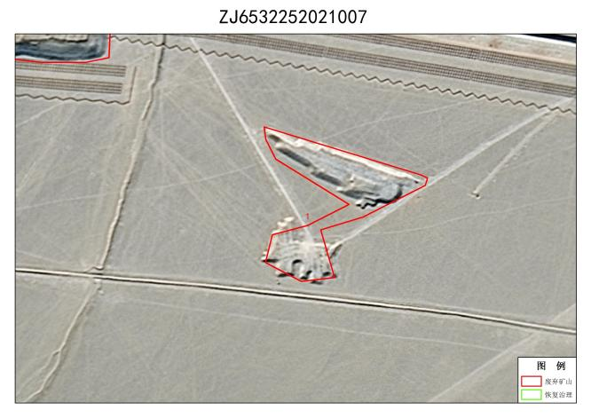
28 | ZJ6532252021008001 | 无法确认治理恢复责任主体的无主废弃矿山 | 和田地区策勒县策勒镇，和若铁路以南74米处，策勒镇直属。 | 250134.39 | 80.8483 | 36.968445 | 1,4092821.40,27485784.69；  2,4093011.04,27486079.95；  3,4092934.55,27486348.08；  4,4092780.74,27486422.84；  5,4092624.00,27486351.40；  6,4092448.90,27485884.51；  7,4092468.08,27485785.37 | 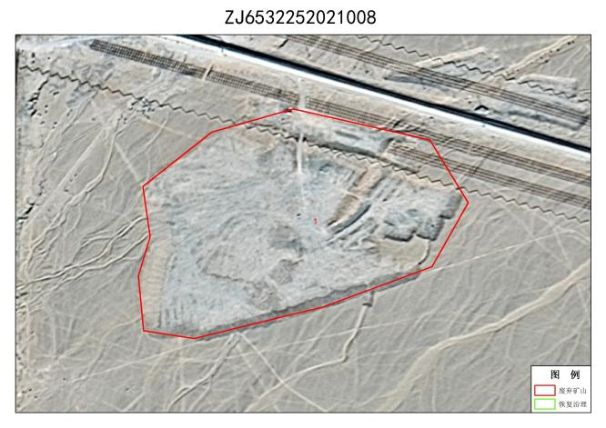
29 | ZJ6532252021009001 | 无法确认治理恢复责任主体的无主废弃矿山 | 和田地区策勒县固拉合玛镇，和若铁路以北857米处，属于固拉合玛镇直属。 | 64328.33 | 80.92038 | 36.96391 | 1,4092652.74,27492728.98；  2,4092534.21,27493078.40；  3,4092400.23,27493143.63；  4,4092381.30,27493021.53；  5,4092475.40,27492803.29；  6,4092552.70,27492675.85 | 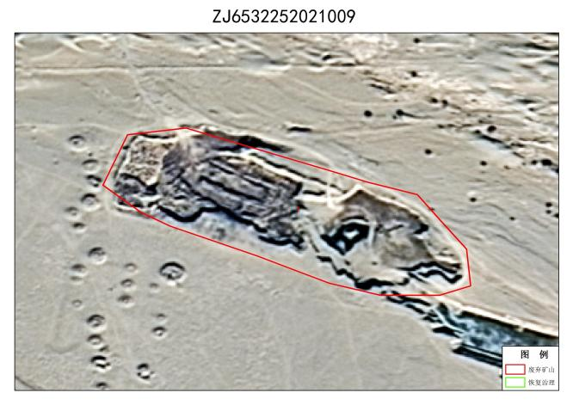
30 | ZJ6532252021010001 | 无法确认治理恢复责任主体的无主废弃矿山 | 和田地区策勒县固拉合玛镇，和若铁路以北309米处，属于固拉合玛镇直属。 | 139808.98 | 80.92398 | 36.959625 | 1,4092339.01,27493153.89；  2,4092289.58,27493428.95；  3,4091776.59,27493329.70；  4,4091875.15,27492958.71；  5,4092239.06,27493212.12；  6,4092282.90,27493108.79 | 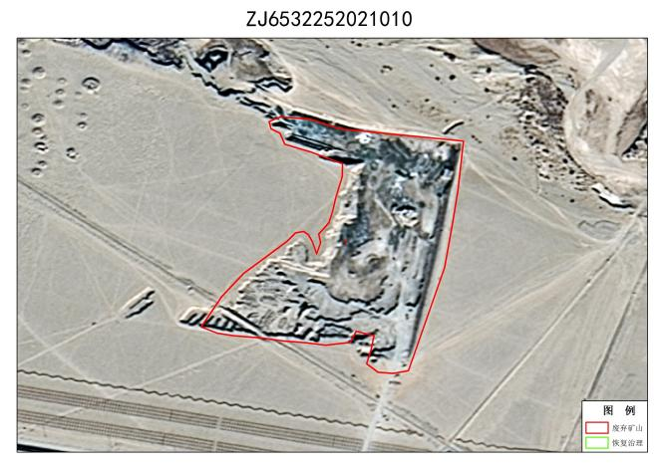
31 | ZJ6532252021012001 | 无法确认治理恢复责任主体的无主废弃矿山 | 和田地区策勒县策勒镇恰合玛村以南，策勒县工业园区以北，属于策勒镇直属。 | 717518.56 | 80.846375 | 36.986176 | 1,4095530.06,27485718.71；  2,4095419.59,27487089.05；  3,4094935.76,27487018.58；  4,4094693.57,27486535.20；  5,4094923.63,27486336.43；  6,4095003.92,27486000.03；  7,4095209.80,27485743.76 | 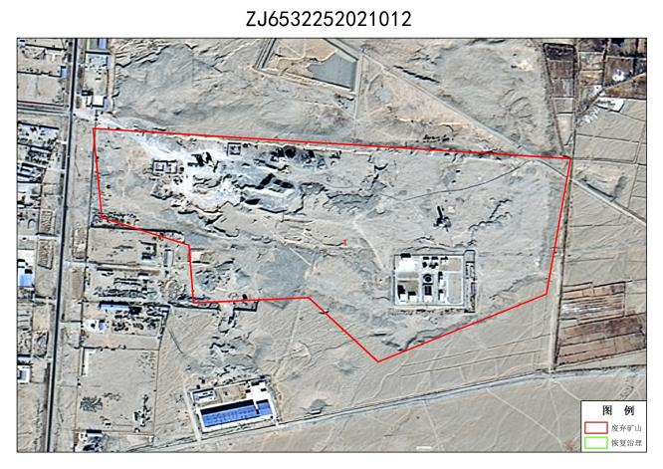
32 | ZJ6532252021013001 | 无法确认治理恢复责任主体的无主废弃矿山 | 和田地区策勒县固拉合玛镇，民丰至洛浦段高速公路以南米295处，属于固拉合玛镇直属。 | 76662.23 | 81.02937 | 36.995792 | 1,4088012.92,27497330.09；  2,4088104.79,27497410.26；  3,4088107.92,27497541.28；  4,4088068.28,27497641.76；  5,4087995.39,27497674.81；  6,4087868.64,27497670.96；  7,4087770.46,27497481.39 | 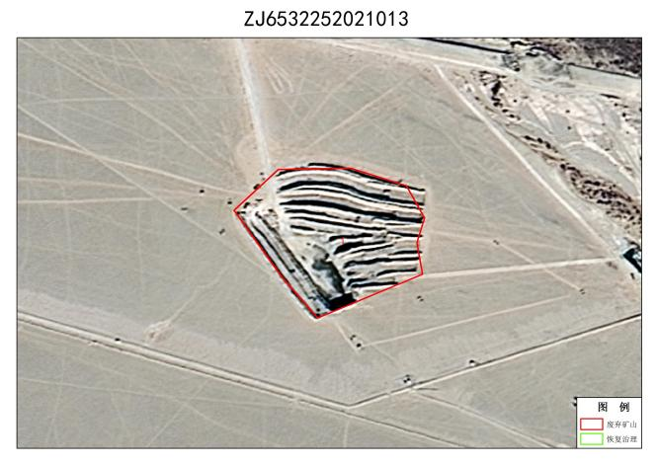
33 | ZJ6532252021014001 | 无法确认治理恢复责任主体的无主废弃矿山 | 和田地区策勒县固拉合玛镇，民丰至洛浦段高速公路以南米513处，属于固拉合玛镇直属。 | 113081.41 | 81.031586 | 36.99597 | 1,4088132.60,27493335.14；  2,4088198.91,27493637.09；  3,4087949.53,27493622.99；  4,4087741.48,27493735.97；  5,4087642.31,27493576.46 | 